Week 4 readings

Ch 8 forms

* Forms contain input fields, select menus and buttons
* Common types of form control – input, select, textarea, button
* Check boxes and radio buttons
* Hidden input fields – must have type = ‘hidden’
* Input file – must have type = ‘file’
* JSON.stringify() – turns form into JSON representation
* Submit button – can be disabled

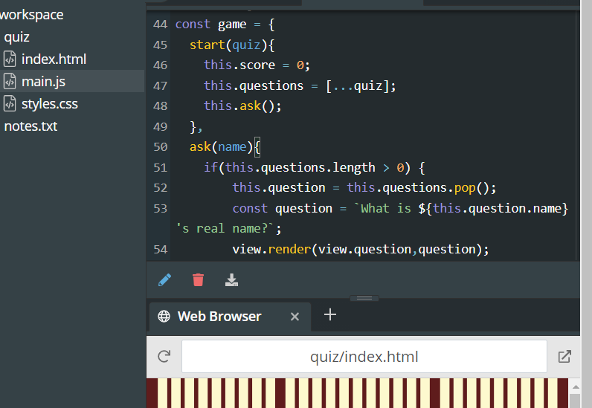

Ch 12 object-oriented programming

* Separating code into objects that have properties and methods
* Inheritance – taking features of one object then adding some new features
* This – represent the object
* Constructor functions or class declarations are capitalized
* Constructor property – returns constructor function that it created
* Static – used in class declarations to create static method (class method)
* JavaScript uses prototype inheritance model – every class has prototype property which is shared by every instance of class
  + Always returns an object
* Object.getPrototypeOf() – makes parameter
* Prototype can be used to add any new properties and mthods after class has been declared
* Prototype chain – chain of inheritance
* Extends – class declaration keyword
  + Inheriting a class form another class
* Polymorphism – different objects can have same method
  + toString() – good example of this, since different objects would need to use it
* getters and setters
  + can be used to control how property is set using assignment
  + good at controlling properties in classes
* Mixins – adding properties and methods of some objects to another object

Ch 15 modern javaScript

* Libraries – piece of code that provides several methods that make it easier to achieve common tasks
* jQuery – most popular javascript library
* advantages of libraries
  + used by lots of people, thoroughly tested
  + code can be bullet proof
* disadvantages of libraries
  + need to include code of library as well as your own
  + downloading
* default exports – refer to single variable that can be imported without having to be explicitly named
* package manager – directory with one or more files of code